CHAPTER THREE
DESIGN METHODOLOGY
3.1 OVERVIEW OF THE PROPOSED SYSTEM
This FutureTrack App is for searching institution information for junior schools students and senior schools focuses on creating a structured, efficient, and user-friendly approach to gathering, filtering, and presenting relevant data. The goal is to help students find necessary details about educational institutions, such as programs, admission requirements, fees, faculty, and campus facilities.
At this stage, the information gathered were analyzed and restructured into a more relevant and useful data. Data analysis and restructuring was based on the identification of the basic needs and the structure required for the project. The information gathered were that the analyzed and restructured in such a way that the subsystems and the modules were achieved efficiently. The analysis and restructuring of these data were such that the system is capable of presenting one frame at a time to the user.

3.1.1 METHOD OF DATA COLLECTION
Having achieved the software requirements, the next step was to source for information relative to the subject. This process of information gathering was achieved through so many sources including:
- File downloads from the Internet
- Textbooks in the library
- Newspaper, Journals and articles
- Other publications
- Personal observations.
- Institution websites
- Government education portals

3.1.2 OBJECTIVE OF THE EXISTING SYSTEM
The objective of the system is to develop searching career institution for junior and senior secondary students that will aid in searching for institution details to help them in their career.



FIGURE: 1.1 OBJECTIVE OF THE EXISTING SYSTEM
3.1.3 INPUT ANALYSIS
The input to the new system is student’s login form, student’s forum dialogue space, question setting form, and answer form. These forms are captured online and contain details of the user, the questions and answers.

3.1.4 PROCESS ANALYSIS
The answer supplied by the user is processed by accessing the institutions details and jobs details, and get more information about the institution and jobs.

3.1.5 OUTPUT ANALYSIS
The output from the system is to let the student know their career and how they can get started. The FutureTrack system also forms part of the output.

3.1.6 PROBLEM OF THE CURRENT SYSTEM
Without FutureTrack, it will be difficult for student to learn fast. Experts are not readily available, so there is need to have a knowledge based system that can be used to train students in various fields of learning and to know the best institution to have their education.

3.1.7 JUSTIFICATION FOR THE NEW SYSTEM
FutureTrack App can provide benefits for the organizations and individuals involved. It provides students with the opportunity to learn fast, get skills and have a wide knowledge. Internet access makes learning easy, obtainable, and affordable.

3.1.8 DATA PROCESSING
Data processing involves the manipulation and processes involved in displaying the institution and jobs information for student so that can get started with their education. These processes start from the school administrators, follow by administrator’s (staff) to the student. All resources are uploaded to the system by the admin into the system where the student can search for a desired institutions. All vital records are stored in the database for future purpose. All the processes are being strictly authenticated and validated to ensure data integrity.

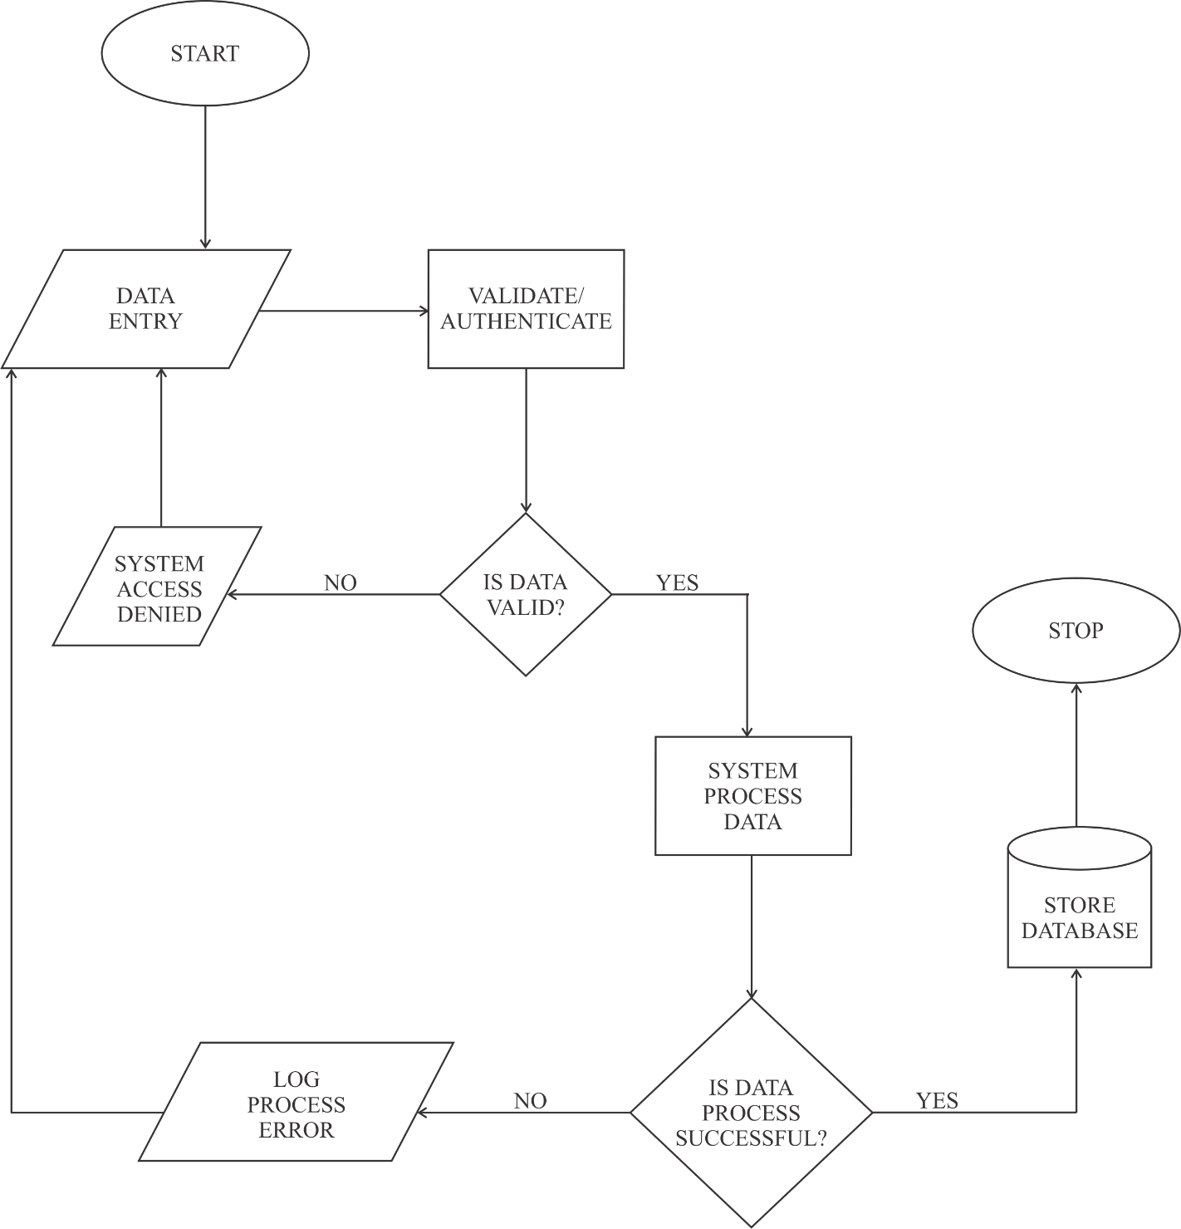

FIGURE: 1.2 FLOW OF DATA IN DATA PROCESSING MODULE

3.2 SYSTEM ARCHITECTURE
Below is the application architecture which shows a graphical representation of the application, views, and database. It also shows the connections and interactions that can be carried out in the system.

ADMIN PORTAL

STUDENT PORTAL

DATA PROCESSING & STORAGE

FIGURE: 1.3 SYSTEM ARCHITECTURE
3.3 SYSTEM FLOWCHART

NO
NO

YES YES
ADD & PUSHBLISH INSTITUTION, NEWS, BLOGS, FAQ’s
SEARCH INSTITUTION, JOBS, NEWS & BLOGS

CHATBOTS

SETTINGS

FIGURE: 1.4 SYSTEM FLOWCHART

